**9th May – Blog date needs to be after 10th May 2015**

**TALES OF THE PIED PIPER – SOUTH LONDON STORYTELLING EVENT**

By Kate Long, Managing Director

As we all live and work in South London, supporting our local community is important to all of the team at Rethink Interiors. After visiting a local supplier we heard about Wandsworth Fringe Arts Festival and Furzedown Festival – a quick Google search later and we’d found out about the Tales of the Pied Piper event on Tooting Common. This is a fantastic community event that involves local schools, arts and crafts outlets, community centres and local businesses. Having read about the event on their website <http://southlondonstorytelling.com/> I knew we just had to get involved and offer to assist in any way possible!

One of our key tasks was to make decorations to help enhance the festival feel of the day. Our team utilised old samples we had in the office (which helped organise our library too!) to hand make 66 metres of bunting, decorative folded fan mobiles, and paper flowers. It was a proper team effort and we all enjoyed letting our natural creativity come out to play!

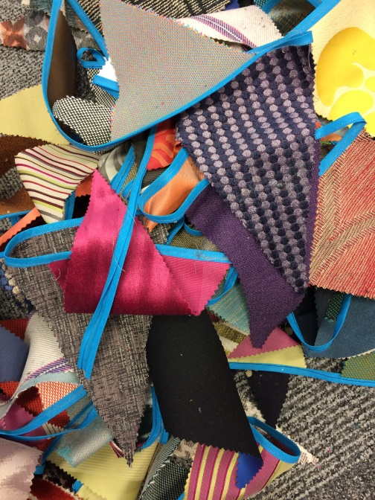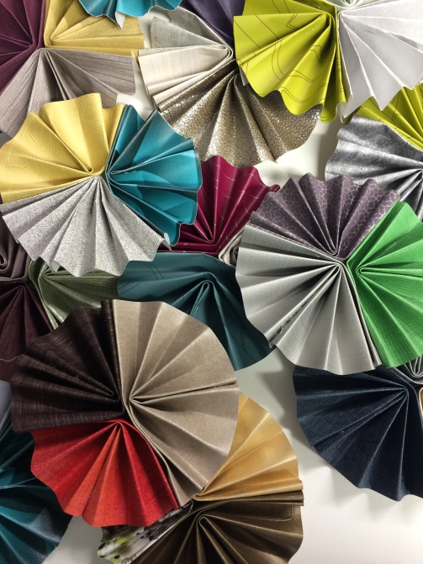

On the day itself I volunteered my services (along with friends and family that were willing to come along and lend a hand – thanks all!) to help set up the site and decorate the tents. This is how the Chill Out Yurt looked when we’d finished with it:

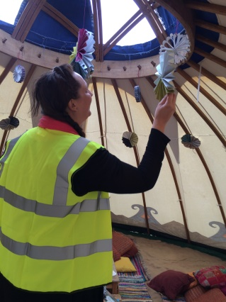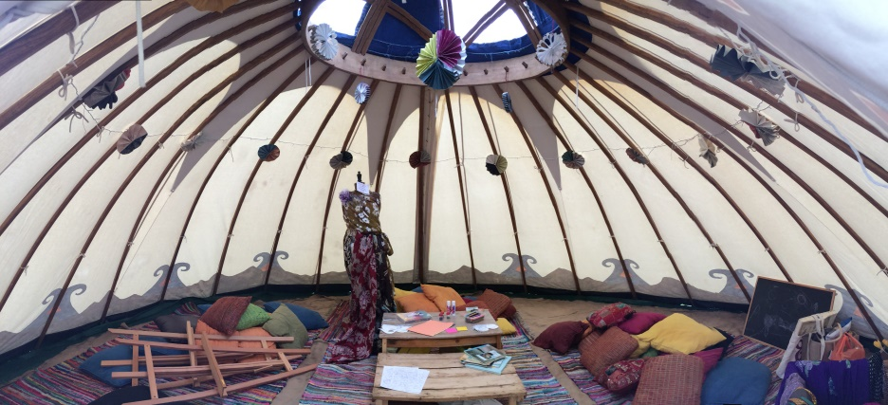

The bunting was put to use decorating the Beer and Story Slam Tent plus Storytelling and Dance Tent (33m in each of them – they were big tents!):

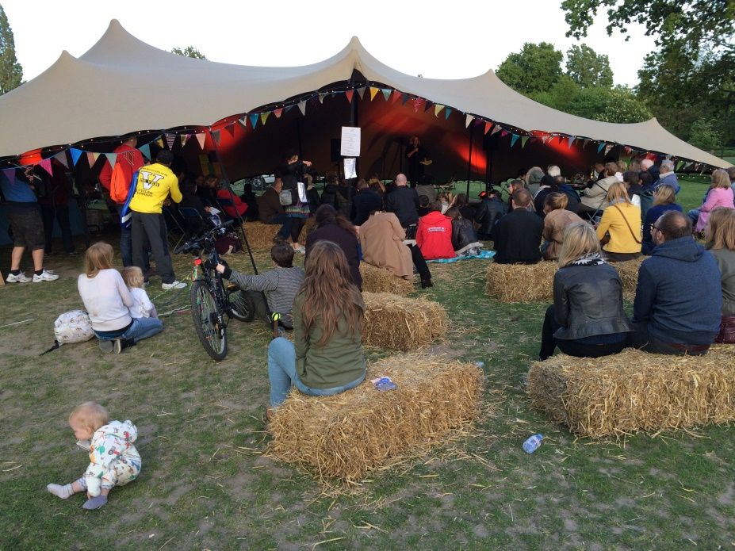

I was also given the task of MC’ing the Beer and Story Slam Tent in the afternoon which was great fun. It was fantastic meeting all the acts and watching them perform. One of the highlights was definitely seeing all the children enjoying the Interactive Speed Painting held by Alina Gavrielatos – I’ve never seen so much paint! Below is the final masterpiece which was truly a community collaboration!

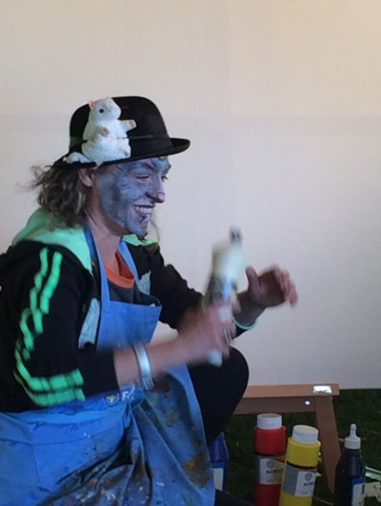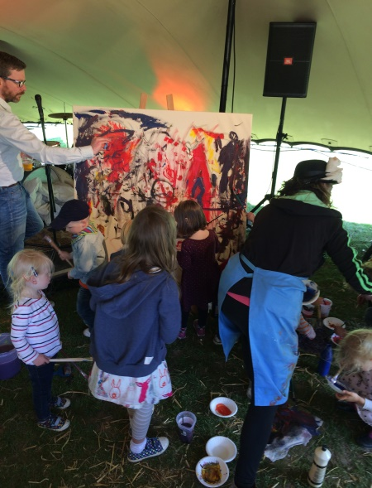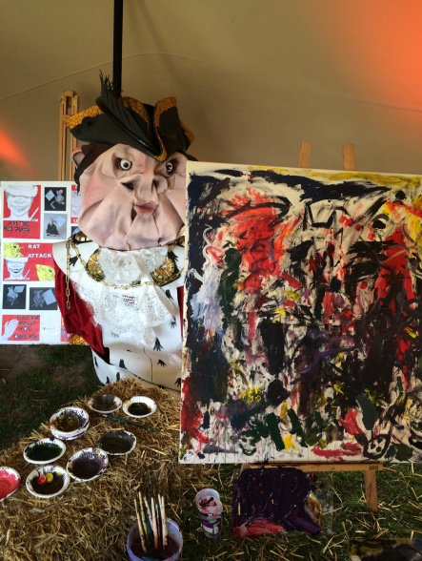

Music acts that played in the Beer and Story Slam Tent included O’Connell and Love; Alex Hulme; Yasmin Corrigan and Milly Upton – the latter three can all be seen again as part of The London FolkFest 2015 at The Bedford, Balham <http://www.thelondonfolkfest.com/>

With a steel drum band, performance art, face painting, maypole dancing, Rangoli art, Chalk the Sun Story Slam, food stalls, games, and many other activities and stalls there really was something for all the family to enjoy. It was great to see so many people out and about enjoying themselves!

All in all it was a fabulous event – the sun shone, music played, stories were told, and new friendships were formed. We loved every minute of being a part of this amazing local event and can’t wait to help out again next year!

